lesson 3 report

Anna Gschwendtner

# Introduction

We analysed how common the name “Page” was in the United States in between 1900 and 2000. We used data from the USA Social Security Administration on baby names. We used linear regression to analyse the change of the name over time, and the difference of the name’s popularity between men and women.

# Results

## Prevalence by Year

We built a linear model to test the effect of year on the proportion of people with the name “Page”. Proportion was log base 10 transformed, because it was not normally distributed. There was no significant change in the popularity of the name over time. The positive coefficients indicates a slightly increasing slope over time.

year.plot

`geom_smooth()` using formula = 'y ~ x'

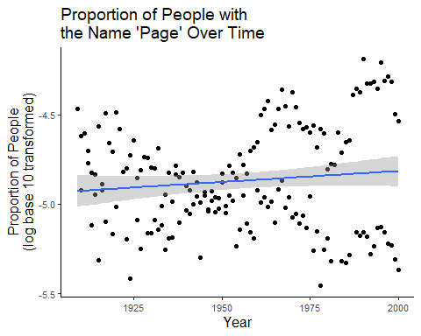

year.lm_sum

Call:  
lm(formula = prop_log10 ~ year, data = data_stats)  
  
Residuals:  
 Min 1Q Median 3Q Max   
-0.61168 -0.21669 -0.01011 0.21070 0.63950   
  
Coefficients:  
 Estimate Std. Error t value Pr(>|t|)   
(Intercept) -7.2755739 1.6258109 -4.475 1.39e-05 ***  
year 0.0012298 0.0008314 1.479 0.141   
---  
Signif. codes: 0 '***' 0.001 '**' 0.01 '*' 0.05 '.' 0.1 ' ' 1  
  
Residual standard error: 0.2855 on 172 degrees of freedom  
Multiple R-squared: 0.01256, Adjusted R-squared: 0.006821   
F-statistic: 2.188 on 1 and 172 DF, p-value: 0.1409

## Prevalence by Sex

The name is more popular among women then men.

sex.plot

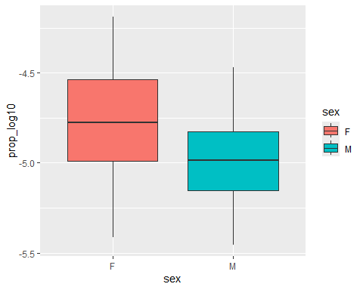

sex.lm_sum

Call:  
lm(formula = prop_log10 ~ sex, data = data_stats)  
  
Residuals:  
 Min 1Q Median 3Q Max   
-0.65876 -0.19694 -0.01178 0.18304 0.56589   
  
Coefficients:  
 Estimate Std. Error t value Pr(>|t|)   
(Intercept) -4.75465 0.02860 -166.244 < 2e-16 ***  
sexM -0.22706 0.03999 -5.678 5.7e-08 ***  
---  
Signif. codes: 0 '***' 0.001 '**' 0.01 '*' 0.05 '.' 0.1 ' ' 1  
  
Residual standard error: 0.2637 on 172 degrees of freedom  
Multiple R-squared: 0.1578, Adjusted R-squared: 0.1529   
F-statistic: 32.24 on 1 and 172 DF, p-value: 5.698e-08

# Conclusion

Text